Experiment Plan: Improve Sales for grocery stores

**The problem**

A grocery retailer saw last year a decline of their sales.

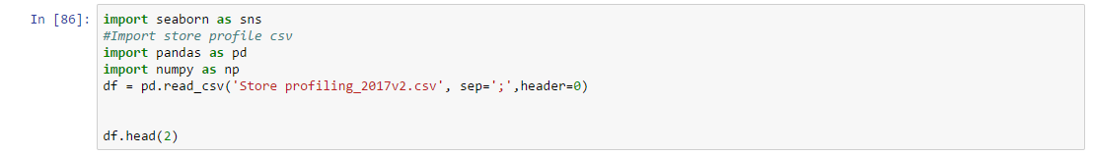

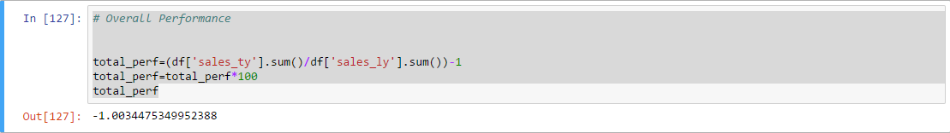

Their sale has decreased by 1% over the last year.

To understand the root cause, their data science team has been testing different features.

On key features that they have identified as an important factor is the price sensitivity of the stores.

Price Sensitivity is a store segmentation allowing to better understand the profile of customers that are visiting their store.

Their price sensitivity segmentation helps to understand how price is important for the customers. Stores are classified into 3 segments: Price Sensitivity, Mid-Market and Up Market.

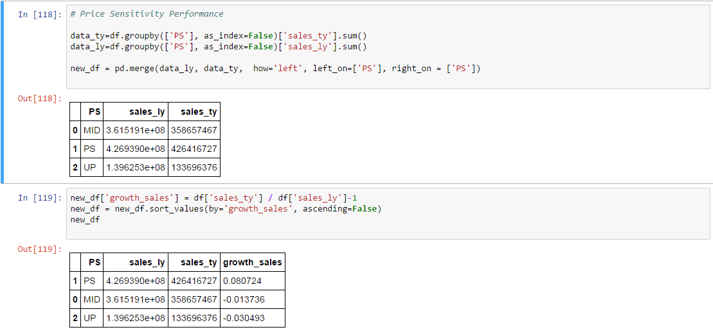

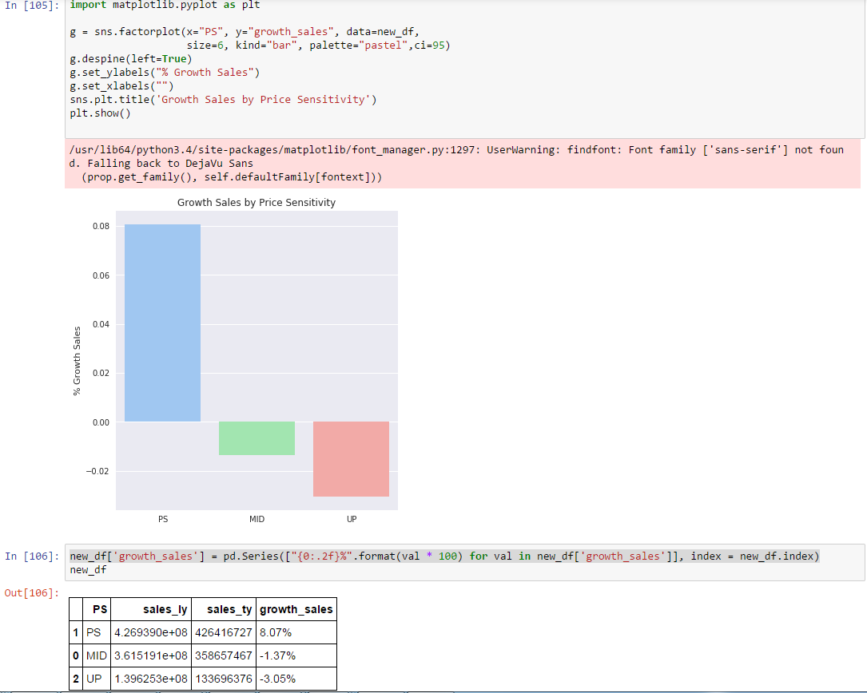

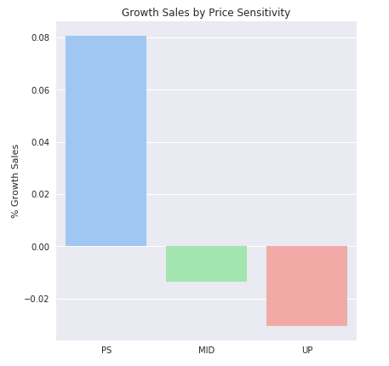

What they clearly identified is that that the decline of sales is mostly driven by the UP Market stores.

* Price Sensitive stores have grown by 8%
* Mid-Market stores have declined by -1.3%
* Up Market stores have declined by -3%

**The potential solution**

In order to improve the performance of their Up Market stores, the management has decided to improve their range of products.

They would like to introduce, new products, new innovations that are appealing to Up Market customers.

**The method of testing the solution**

However, in order to know if this new initiative could help the Up Market stores to grow, it has been decided to undertake a pilot.

The Up market stores will be therefore split into 2 groups of stores.

The 2 groups will be similar in terms of customer profile, sales pattern, seasonality.

The first group will receive the new Up Market range and the second group of stores will keep the current range of products.

The variable of interest is sales growth.

An A/B manipulation will be undertaken where new range is implemented or not implemented.

We will compute the sales growth for a quarter before the study and compare it to the sales growth with the two groups of stores for a quarter during the study.

If sales growth in the next quarter increased by 2% point among the store with the new range compared to the store keeping the same range, we conclude that new range is effective and roll it out.

If conversion rate in the next quarter increase among the new range stores, but by less than one standard deviation, observe one more quarter before deciding.

If sales growth decreases in quarter we will remove the new range.